**The Scenario:**

A University contains many Faculties. The Faculties in turn are divided into several Schools. Each School offers numerous programs and each program contains many courses. Lecturers can teach many different courses and even the same course numerous times. Courses can also be taught by many lecturers. A student is enrolled in only one program, but a program can contain many students. Students can be enrolled in many courses at the same time and the courses have many students enrolled.

**The entities in this scenario are**:

 University  Faculty  School  Program  Course  Lecturer  Student

**Attributes, primary keys (in bold black) and foreign keys (in bold blue) are shown below:**

University (**name**, address, type, VC)

Faculty (**name**, dean, location, **university**)

School (**name**, HoD, location, **faculty**)

Program (**name**, total credits, duration, **school**)

Course (**code**, name, credit hours, coordinator, **program**)

Lecturer (**emp_code**, name, designation, room, **school**)

Student (**reg_no**, name, **program**, email, cell, address)

**Relationships:**

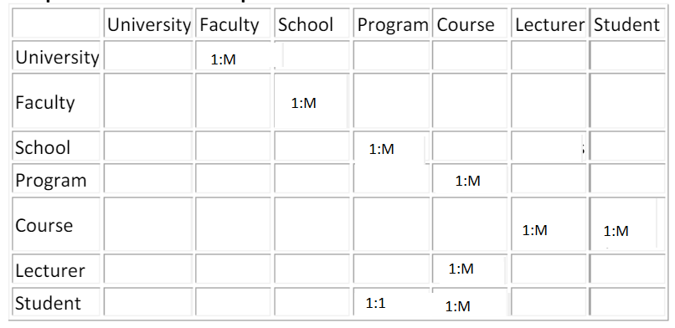

Here we have identified the relationships and we can see that student-course and lecturer-course exhibit many-to-many relationship and we need to introduce another entity to break this M:M relationship.

**Here come two more entities:**

**1- Course Registration (reg_no, course_code, date, assigned_by)**

Combination of reg_no & course_code serves as primary key for this table. reg_no & course_code are also foreign keys here as they are primary keys in their respective tables.

**2- Course-Allocation (emp_code, course_code, date, assigned_by)**

Combination of emp_code & course_code serves as primary key for this table. emp_code & course_code are also foreign keys here as they are primary keys in their respective tables.

**Now you can create ERD based on these 9 entities and their identified relationships. (A rough sketch in given below).**

Course  
Allocation

Lecturer

Registration

Program

Course

Student

School

Faculty

University